


Design documentation
Control mode within Papyrus

Editor | <Emilien Perico - AO>
Status | Draft version
Version number | 0.1
Date of preparation | 12/04/10

Editors and Authors
Editor name (first/last name) | Company | E-mail | Initial

Authors name (first/last name) | Company | E-mail | Initial
Emilien Perico | AO |  | EP

Revision chart and history log
Version | Date | Reasons
0.1 | 12/04/10 | Initial version
Table of contents
Editors and Authors 2
Revision chart and history log 3
Table of contents 4
List of figures 5
1 Introduction 6
2 Resource Loading 7
2.1 Use Case with the controlled resources 7
2.2 Pessimistic policy 8
2.3 Proposals 8
3 Management of proxy object 9
3.1 Label Providers for Proxies 9
3.2 Proxies in the Graphical Editor 10
4 UML profiles management 12
4.1 Requirements 13
5 Historic format of control actions 14
6 Summary and conclusion 15
7 References 17

List of figures

Introduction
Requirement: the reader should read the minutes of meeting 20010-03-16 available on the papyrus svn from the following link:
http://dev.eclipse.org/svnroot/modeling/org.eclipse.mdt.papyrus/trunk/doc/PapyrusTechnicalMeetings/08%20-%20Technical%20Telco%20Meeting%20%282010-03-16%29/
The document explains the expected behavior of the partial resource loading. The chosen solution is the one where only needed resources are loaded.
To remind you, in this solution, a project is made of several resources representing the unit of control. A user is assigned a set of resources that it can modified. It is possible to load only the assigned resources and resources required by them.

The following table provides a glossary defining a set of terms needed to understand the following discussions:
Resource | An Eclipse Resource. Usually a file.
ResourceSet | A set of resources. In Eclipse EMF, a ResourceSet contains several Resources that are managed together. Especially, references between resources are maintained by EMF.
Control / Uncontrol | Action of controlling a resource. That is, the resource is split in two separate resources. Cross references are maintained between resources if they are in the same ResourcesSet.
Project (name subject to change) | A collection of related files.  Example: all the .di, .notation and .uml used to render one UML model in Papyrus form a project.  In its simplest form, a project contains one .notation, one .di and one .uml.
References Resolving | Action of resolving references of a controlled model. This maybe required when a controled model reference element in another model that as been modified.

Resource Loading
Here is the resource loading process and the interactions with the resource set when you open a .di resource.
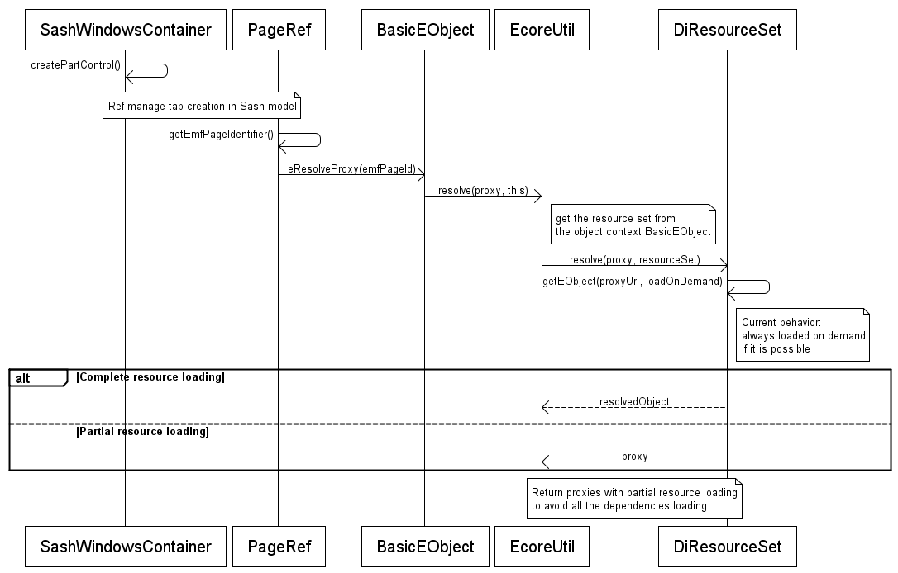

For now, the resource set is in charge of resolving the proxies on demand. A resource is loaded when a proxy object needs it.
In the case of the partial resource loading, we don't want the load the needed resources and only manage the proxies. This process allows the opened resource to be independent of some initially needed resources.
Of course this behavior won't be always performed. A Proxy manager could manage several policies to decide what is done for each type of resource. For example, we can decide that all the pathmap are loaded but not the platform resources, decide what is done for UML profile resources, etc. We will call this parameter : “Loading Policy”

Use Case with the controlled resources
When you are opening a controlled resource, this one could be independent of the parent resource using proxies.

When you are opening the high level resource which depends on controlled resources, the process asks the historic (see Action 6) to know where the unresolved objects have been moved to be able to load it.

getPageRef(): resolve proxy
MyModel.di

Package1.di
Control package1

Package2.di
Control package2

getEObject(): return a proxy

Pessimistic policy
For performance reason, we choose the partial resource loading instead of loading all the needed resources. The number of resources to load can be too high.
This solution needs to maintain an historic of the control/uncontrol command. In some cases, it could be more wasteful to maintain this historic instead of loading all the resources.

A preference should exist that allows the user to choose between both modes: partial resource loading vs. all resources loading (ie. Special Loading Policy)

Proposals
An advanced feature would allow the user to know the unloaded resources that the current model is dependent with and enables him the load a specific resource if he needs it.
We don't talk about read-only mode here. Does an additional resource be loaded in read-only mode or not. Additional resources management is another point we must address too.
Resources loaded by the user will be stored to avoid him to do the same the next time he opens the model.

Management of proxy object

Label Providers for Proxies
A proxy object is not resolved because its container resource is not loaded. The only information we have is its type and its uri. Because of this lack of information, we should take care of the proxy object label provider in the editor.
For now, a proxy is displayed in this way in the model explorer and the advanced properties view: <ProxyType>, for example <Class> or <Property>
Graphically, a proxy is replaced with null value in a diagram.
For example, here is a model with some references:
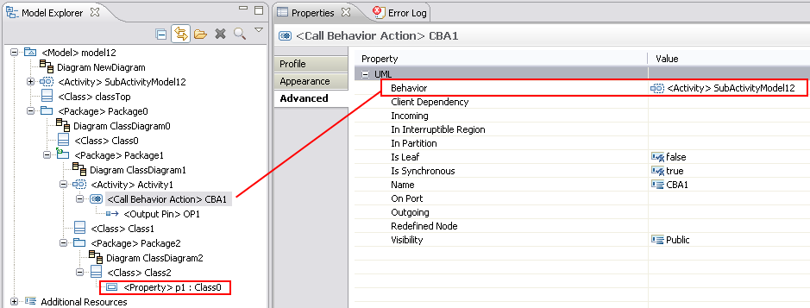
You can see that Package1 is controlled and references some element on the model12 (Activity SubActivityModel12 and Class 0).

Now if I open Package1 resource keeping proxies:
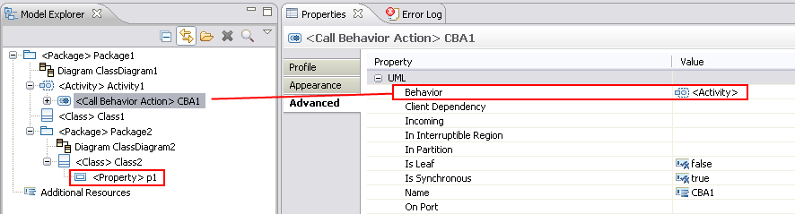

There is no dependency to Mode12 even if there are references to it. Proxies are not resolved and only displayed with their types.

For these reasons, the label provider must be overridden to clearly identify a proxy in the editor (diagram, properties view and model explorer).
You can see above the process, when the label provider try to display a property value:
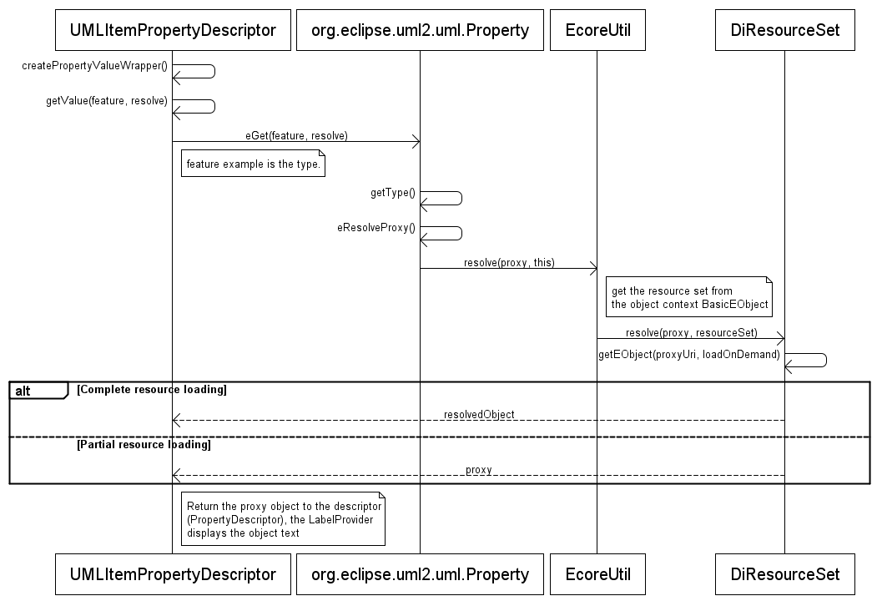

Proxies in the Graphical Editor
Another use case with proxies is in the graphical editor. Using the same example above, we can use an element (for example <Class> classTop) from the model12 resource on a diagram (ClassDiagram1)

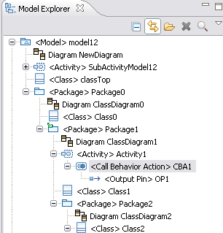
When you try to open Package1.di, classTop is a proxy because model12 is not loaded. For now an exception occurs. We must fix parts of code where proxy are not managed and decide what is done in this case:
- warning message for the user to explain that the resource needs some dependences and load it,
- or use a specific figure to display a proxy object in a diagram.

UML profiles management
There are some behavior we must take care for UML profile management and control mode.
When you apply a profile on a model, a profile application is created. Then you can stereotype your elements:

For example, here is a model with Ecore profile applied:
You can see that eGenericType stereotype is applied on Class1
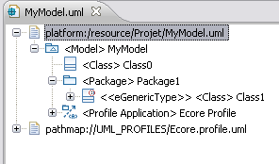
The I control Package1 element, you can see that I lost the applied stereotype. EMF doesn't find the profile application on the resource and it delete the stereotype application.

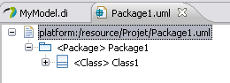
The only current way to restore the applied stereotype is to load the parent model as additional resource. But we don't want to be dependent of the parent model in the controlled resource.

To avoid the parent model loading, the profile application can be duplicated and applied on the root of the controlled resource (Package1 in the example). This task must be transparent for the user.
You can see that we keep the stereotype application.
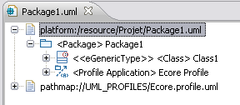

Requirements
Profile-mngt-req1: A duplicated profile must not be unapplied to keep the consistency on the controlled resource. That's why a duplicated profile application must be annotated to be identified as duplicated. This allows the developer to disable the unapplied profile action on it.

Profile-mngt-req2: Control action is available on all the eObject that resolves proxies. But you only can apply profile on Package. The follow the profile application, only package can be controllable. We must restrain the Control Action on Package.

Historic format of control actions
Some explanations about this point we talked about in the previous meeting
- References resolving need a kind of absolute identification of elements. ATOS thinks that the 'uid' used in models can be used for the resolving. That is, the uid of an element is made of the name of 'resourceName/anUid'. Even if the element is moved from one resource to another, its uid doesn't change. So it should be possible to find the element by looking the uid in the resources where the element can have been moved.

Actually, the notation models doesn't use unique id but relative id. This format doesn't allow us to find an element in the new resource.
The historic format should use a kind of map or a tuple with the old reference (store the old URI and not the EObject) and the new one in order to find a specified element in a controlled resource.

Summary and conclusion
Here is the resulting list of actions:
Be careful, some actions require some other to be performed.
Action Id | Action Description | Who | State
ControlModel::Action1 | Partial Resource loading  We need to check if we can load only a part of the resources.  This action block other actions. If it is not possible to load partially a set of resources, it is not necessary to implement this solution. We must check the feasibility of this risky point before the next steps.The solution 1 should be used instead. | ATOS | OK
ControlModel::Action2 | Control / Uncontrol  Need to implement the action of control/uncontroling: UI, call to EMF, maintain historic.  Control and Uncontrol action will be improved to create the history and maintain it once the format will be defined. | ATOS | In progress.  Waiting for Action 6 (Cédric)
ControlModel::Action3 | Open Close of a diagram  Open action must launch the resolving to fix the proxies if any (using the historic). A dialog box warns the user if resource is not found and asks him where is it. | ATOS | Waiting for Action 6 (Cédric)
ControlModel::Action4 | References Resolving  Need to check if UID can be used for that.  Need to propose an algorithm for references resolving.  There can be several strategies.  We can think about several policies: pessimistic and optimistic. A dialog box could ask the user where the unresolved resource is if we have one. Another solution is a mode that loads all the resources (solution 1).  Basically, this behavior would be improved and we could provide it to resolve corrupted models, independently of the control mode.  This action could be triggered when the diagram is opened or through a contextual menu, maybe using a job to allow background process. | ATOS | Waiting for Action 6 (Cédric)
ControlModel::Action5 | Model Explorer  How the model explorer will render a partial model made of a subset of resources. What to do if some elements are missing (like intermediate packages) ? Manage Label Provider for proxies rendering | Cedric
ControlMode:: Action 5.1 | Graphical Editor  How the graphical editor will render a proxy object figure if a resource is partially loaded ? Need to choose a solution and implement it. | To be define
ControlModel::Action6 | Model to maintain control/uncontrol historic  An historic of control/uncontrol can be used to improve the algorithm of references resolving. The historic can be used to restrain the number of resources to lookup.  The main idea is to add this history in the DI resource and update it after a control and uncontrol actions. | Cedric
ControlMode:: Action7 | UML Profiles Management  specific behavior must be set up for profile when a control/uncontrol action is performed. | ATOS

References

